MEDICAL DIAGNOSTIC TEST CENTER
End-to-End ServiceNow Workflow
Workflow derived from the supplied 21-page ServiceNow implementation reference

1. Overall Workflow
1  Portal Entry | 2  Test Catalog | 3  Select Test | 4  Booking | 5  Patient Details | 6  Schedule | 7  Payment | 8  Done | 9  My Appointments | 10  Test Completion | 11  My Lab Reports
Primary path: Portal Home → Medical Test Catalog → Test Selection → Appointment Booking → Patient Details → Schedule → Payment → Done → My Appointments → Test Completion → My Lab Reports

2. ServiceNow Data Layer
Table / Object | Role in workflow | Key fields visible in reference
PATIENT | Stores patient master information used during booking | Date of Birth, Last Name, Gender, Updates, Address, Created / Created by
DIAGNOSTIC TEST | Stores diagnostic test definitions and details | Test Duration, Description, Updates, Category
APPOINTMENT TABLE | Stores appointment transactions | Rejection Reason, Status, Created, Slot Time, Scheduled Date, Patient, Updated by
REPORT TABLE | Stores diagnostic report information | Report Date, Updated, Report Number, Verified By, Appointment, Sys ID, Patient, Created by

3. Functional Modules / Service Portal Components
Component | Purpose shown in reference
Medical Test Catalog | Displays available diagnostic tests, search/filter capability, availability, pricing, and Book Now actions.
Appointment Booking | Guides the patient through a multi-step booking process: Details → Schedule → Payment → Done.
My Appointments | Displays appointment history/status and provides access to appointment details or a new booking.
My Lab Reports | Provides access to diagnostic test reports/results.
Lab Reports page | Service portal page used to present report information.
Test Catalog page | Service portal page backing the test catalog experience.
Appointment Booking page | Service portal page backing the booking experience.
My Appointments page | Service portal page backing appointment tracking.

4. Detailed Booking Workflow
Step 1 — Discover: Patient lands on the Medical Diagnostic Test Center portal and sees search, My Bookings/My Appointments, and My Reports access.
Step 2 — Select Test: Patient searches or browses the Medical Test Catalog and chooses an available diagnostic test.
Step 3 — Start Booking: Patient clicks Book Now. The Appointment Booking widget presents the progress sequence.
Step 4 — Patient Details: Patient information is captured, including first name, last name, email, phone, date of birth, gender, and address.
Step 5 — Schedule: Patient selects the required appointment schedule/slot.
Step 6 — Payment: Patient proceeds through the payment stage shown in the booking stepper.
Step 7 — Done: Booking reaches the Done stage and the appointment record is stored.
Step 8 — Track: Patient opens My Appointments to see booking status and appointment details.

5. Automation / Business Rule Workflow
Automation | Trigger / configuration visible in reference | Workflow outcome
Auto Populate Medical Appointment on Checkout | Business Rule on the APPOINTMENT TABLE; configured as an active rule and associated with the booking table. | Supports automatic population/creation of the medical appointment during checkout.
Auto Create Report on Appointment Complete | Business Rule on the APPOINTMENT TABLE; active; condition/action configuration shown. | Supports creation of a report when the appointment reaches completion.
rejectionTotalUpdate | Business Rule on the APPOINTMENT TABLE; active; update action and filter condition are shown. | Supports rejection-related update logic on appointment records.

6. End-to-End System Flow
Stage | System Layer | Result
A | Portal Entry | Medical Diagnostic Test Center home page
B | Catalog | Search / browse diagnostic tests
C | Selection | Choose a test and click Book Now
D | Booking | Details → Schedule → Payment → Done
E | Appointment Record | Appointment stored in APPOINTMENT TABLE
F | Business Rules | Checkout / completion / rejection automation
G | Test Completion | Appointment reaches completion
H | Report | Report record is created / updated
I | Patient Access | My Lab Reports displays the report

7. Reference Screens / Evidence
Portal home / landing experience — source page 17
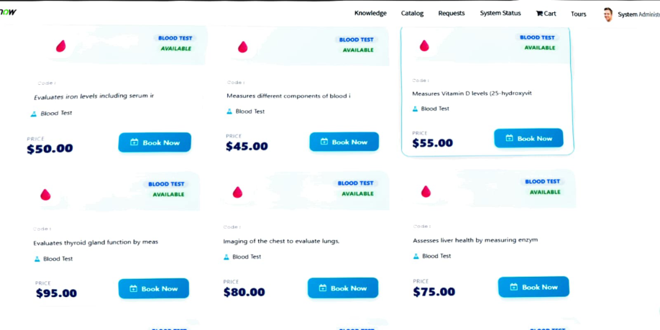
Diagnostic test catalog and Book Now cards — source page 18
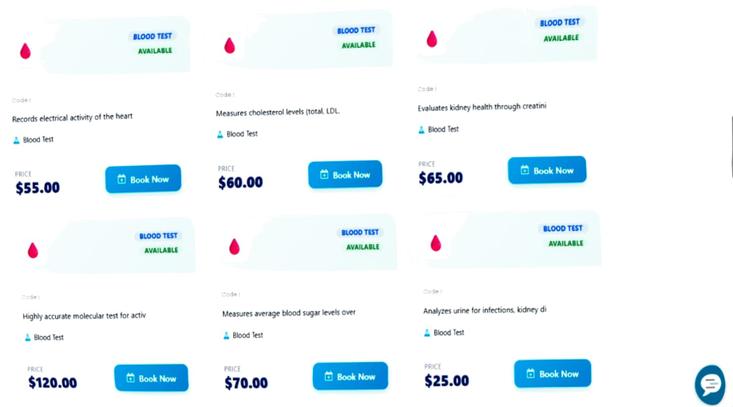
My Appointments view — source page 19
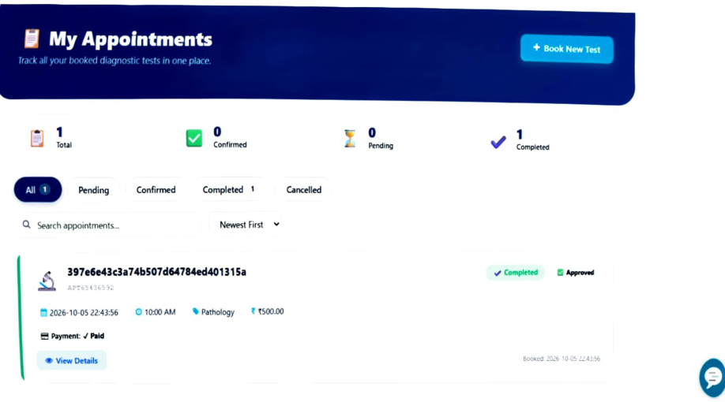
Appointment booking — patient details stage — source page 20
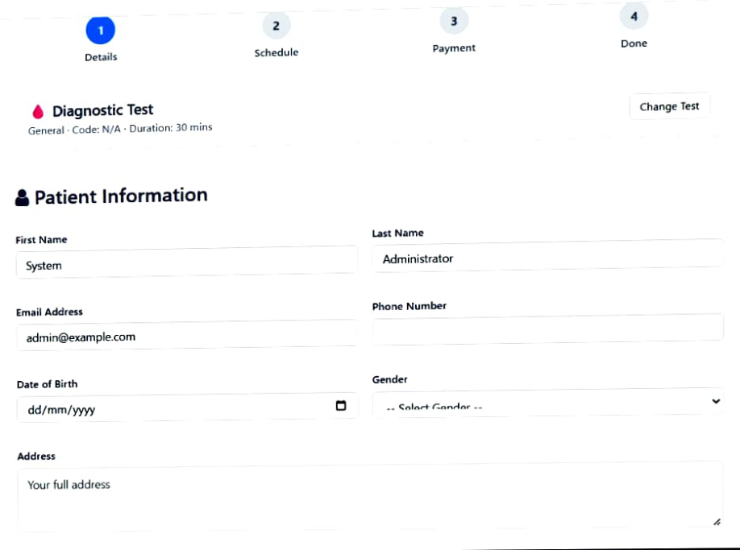
My Lab Reports page — source page 21
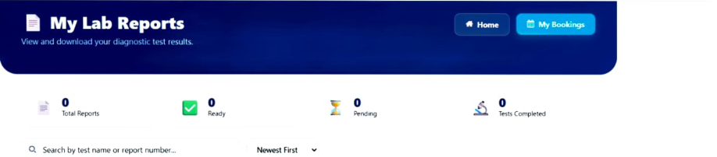

8. Implementation Summary
- The reference demonstrates a ServiceNow Medical Diagnostic Test Center built around portal widgets/pages, diagnostic-test data, patient data, appointment data, and report data.
- The patient-facing journey is centered on test discovery and appointment booking, followed by appointment tracking and report access.
- The booking experience is explicitly represented as four stages: Details, Schedule, Payment, and Done.
- Business rules are used to automate appointment/report/rejection-related processing around the APPOINTMENT TABLE.
- The workflow connects the patient-facing portal experience with the ServiceNow data and automation layer through the appointment lifecycle.

9. Workflow Diagram (Text Specification)
PATIENT
↓
SERVICE PORTAL / MEDICAL DIAGNOSTIC TEST CENTER
↓
MEDICAL TEST CATALOG
↓
SELECT TEST → BOOK NOW
↓
APPOINTMENT BOOKING
├── Patient Details
├── Schedule
├── Payment
└── Done
↓
APPOINTMENT TABLE
├── Auto Populate Medical Appointment on Checkout
├── Auto Create Report on Appointment Complete
└── Rejection Update Logic
↓
DIAGNOSTIC TEST COMPLETION
↓
REPORT TABLE
↓
MY LAB REPORTS
Source basis: WRKFLW.pdf — 21-page supplied implementation reference.

